P.Deepak
Htno:2303a52179
Batch-42
ASSIGNMENT-6.4
Task 1: Student Performance Evaluation System
Prompt:
Write a method to display student details roll number and marks. Write a method to compare student's marks with class average Use self attributes and if-else condition Return a message indicating performance
Code:
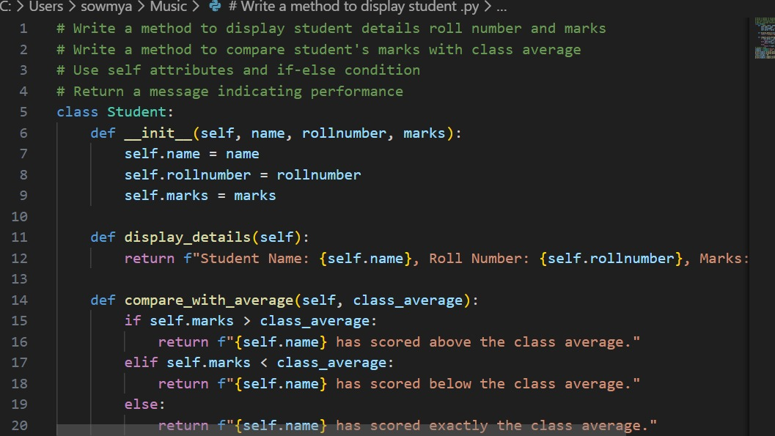
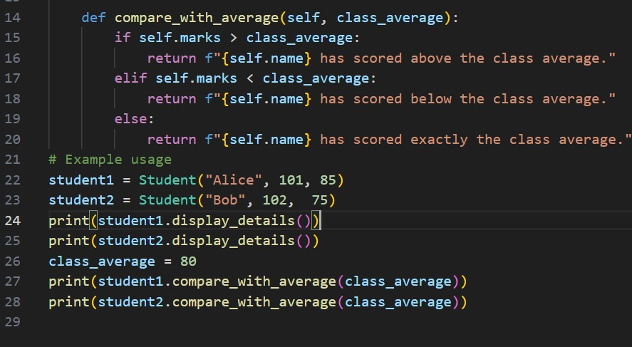
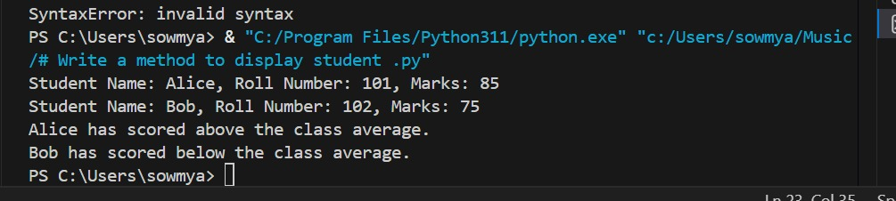
Justification:
The Student Performance Evaluation System is designed to automate the process of managing and evaluating student academic data in a structured manner. A Python class named Student is used to represent real-world student entities by encapsulating essential attributes such as name, roll number, and marks.
Task 2: Data Processing in a Monitoring System
Prompt:
Task: Process Even Sensor Readings with GitHub Copilot

We need to iterate through a list of sensor readings, identify the even numbers, calculate their squares, and print the results in a readable format. The goal is to set up the initial loop and use a comment to guide GitHub Copilot to complete the remaining logic.
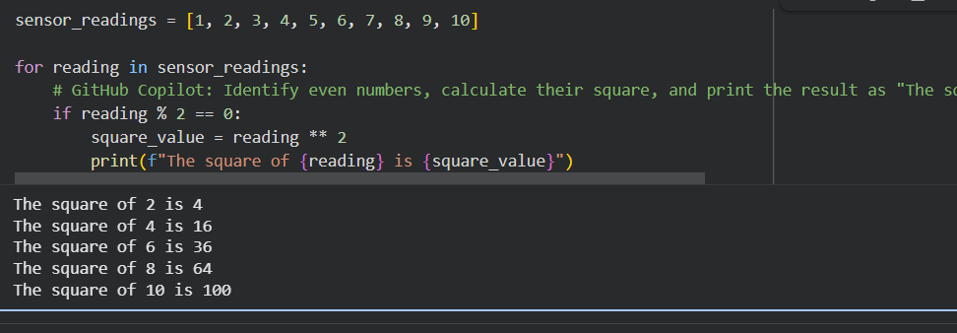
JUSTIFICATION:
The code iterates through each reading in the sensor_readings list. For each reading, it checks if the number is even using the modulo operator (%). If reading % 2 == 0 is true, meaning the number is even, it then calculates the square of that number (reading ** 2) and stores it in square_value. Finally, it prints the result in the specified format: 'The square of [number] is [square_value]'. This process continues until all numbers in the sensor_readings list have been checked.
Task—3
Prompt:
Create a BankAccount classand Attributes:account_holder: name of the customer balance: initial balance
Initial code written: 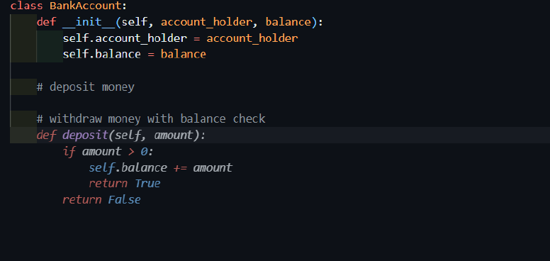
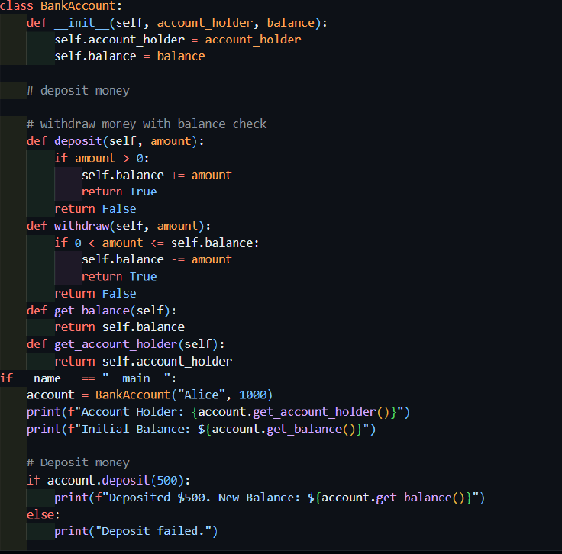
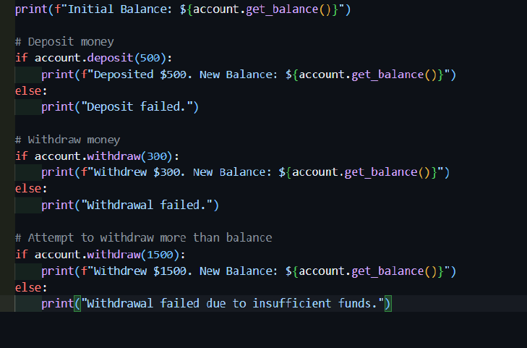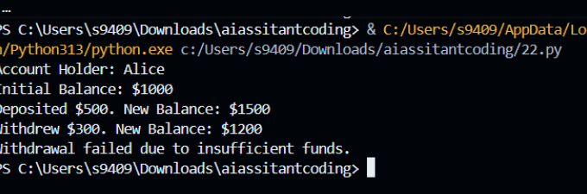
Explanation
● Uses if-else to prevent invalid withdrawals.
● Balance stored as class attribute.
● User-friendly messages generated by AI.

Justification:
The BankAccount class models a real banking entity using encapsulation. The deposit() method updates the account balance safely, while the withdraw() method includes an if-else condition to prevent invalid withdrawals. This ensures data integrity and mimics real-world banking constraints. User-friendly messages improve system transparency and usability, while the use of class attributes (self.balance) ensures consistent state management across transactions.
Task 4: Student Scholarship Eligibility Check
Scenario
A university wants to identify students eligible for a merit-based
scholarship based on their scores.
Initial code written :
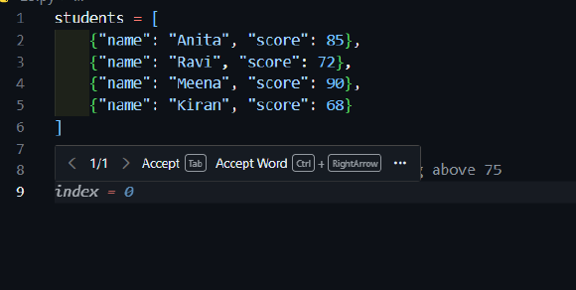
Code generated: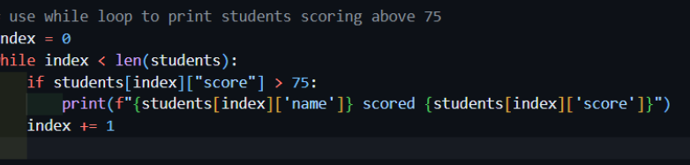
Output:
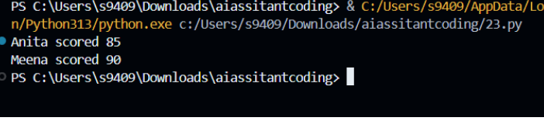
Explanation
● while loop correctly handles indexing.
● Conditional check ensures eligibility filtering.
● Output is clean and readable.

Justification:
A list of dictionaries is used to store structured student data, allowing easy access to names and scores. The while loop iterates using index control, demonstrating explicit loop handling. The conditional check (score > 75) accurately filters eligible students based on scholarship criteria. This approach ensures correct traversal, precise condition evaluation, and clean output formatting.
Task 5: Online Shopping Cart Module
Scenario
Implement a shopping cart with discounts.
Initial Skeleton:
Code generated:

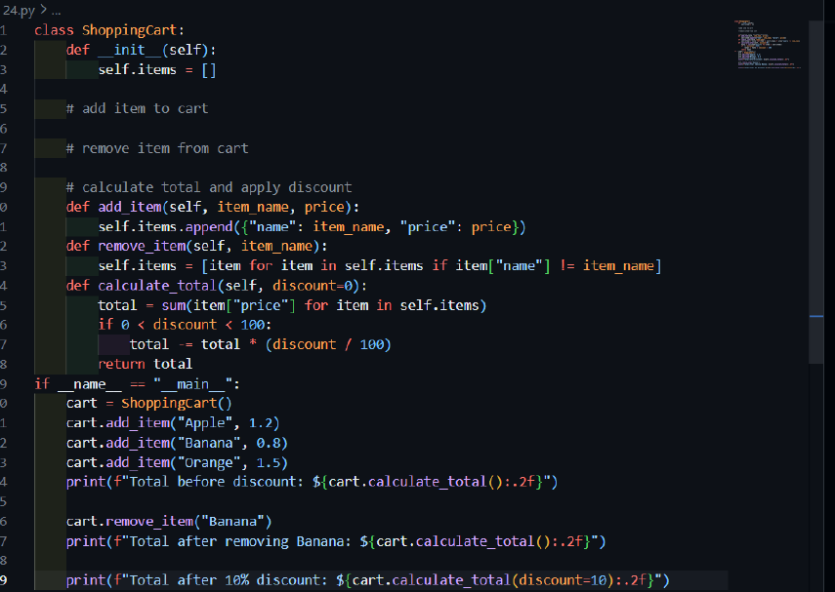
Output:
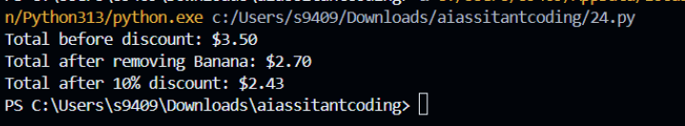
Explanation
● Uses loops to compute total.
● Conditional discount applied automatically.

● List comprehensions used efficiently.

Justification:
The Shopping Cart class uses a list to manage dynamic item storage, enabling addition and removal operations efficiently. The add_item() and remove_item() methods promote modular design and maintainability. A loop is used within calculate_total() to compute the bill accurately, while an if condition applies a discount when a predefined threshold is exceeded. This implementation reflects real e-commerce systems by ensuring correctness, flexibility, and scalability

